19

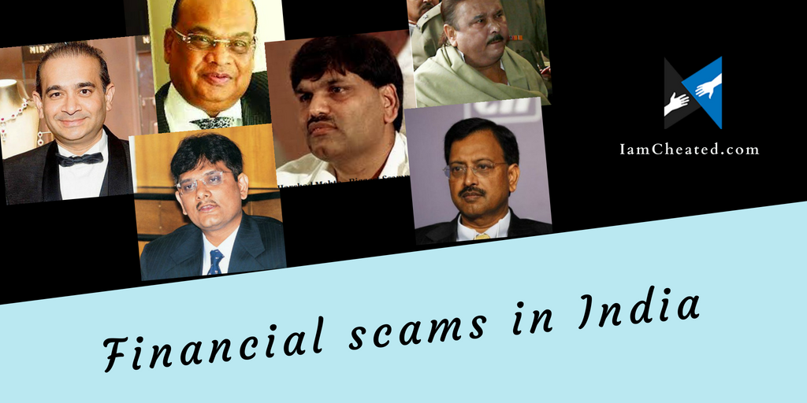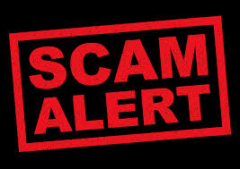

**Can Data Science give a SCAM ALERT?**

SCAM, a word that came from west and created a buzz in India in 1992. Yes we are talking about the biggest scam of that times in back 1990s, The Harshad Mehta scam, but that became very small scam when Ketan Parikh did even more amplified version of what Harshad did, and then gradually increasing numbers of frauds as well as increase in amount, examples are many, Coalgate scam(2004), 2g spectrum scam(2008), Satyam scam(2009), common wealth games(2010), Vijay malya(2016), Nirav modi(2018), this are the big one’s but there are many more on records, Few did not even get a headline in newspapers. The problem is in the system and not in the defrauders as they are showcasing their talent by finding out loopholes in the system and misusing it. Lets just rethink over this scam in general, are these scams really done in 1 or 2 days? NO, are these scams done by single person or few people whose name got highlighted in the news? Again NO, so based on these two questions only we can figure out that, first, whole lot of people were involved directly or indirectly in these frauds, second it took quit long time to do such lakhs of crores of scam.

Well fraud is now no big news. Especially, this pandemic has taught many of us that recession is a favourite season of fraudsters. If this people who can play with our systems, play with our money and show their talent in finding loopholes in the system to manipulate it, why can’t we being educated, knowledgeable and self-efficient being figure out defrauder’s loopholes? Well, Data science can actually do this and it can also create an automated system which needs no human interaction and will directly give a notification to the authorities who can take actions on any suspicious activities. There are many data science tools and techniques that can really help here, such as Artificial Intelligence (AI), Machine Learning (ML), Data Mining, Data matching etc.

“Data is the new oil of the 21st century”- Clive Humby, UK. Data revolves around us, daily 2.5 quintillion bytes of data is generated by us, and its yet increasing because of internet of things, Data comes from varied sources, and in wide range like email, call centres, social media, phones, fax, wearable tech etc. Now data analysis is a process in which you can take out some meaning full story out of this huge data, we can ask any question in any form, data analytic tools will help us to visualise our question’s answer in a most appropriate way.

But how should we use data science in officials and banking and government cases? So here the case becomes easy because banks generate daily so much of grouped data which can directly be seen in excel or csv format, governments are the best source of confidential data of officials, which can then be processed regularly and by input of rules and regulations of government in the software for data analysis an efficient system can be built. This system will then keep an eye on every citizen of India as well as each transaction done by them.

Of course, the process is not that simple as it includes interdisciplinary fields such as math science, computer science, economics, business behaviour, psychology and Laws. But this examination of data can give us weaknesses in systems, loopholes in systems, data gaps, strengths, risk factor, vulnerability, dysfunction etc. According to specialized literature, associated with data analysis as system for prevention and detection of fraud, are often identified over 24 sorts of analysis, a number of them extremely complex, but among all of them, we will identify two classical sorts of analysis: operational analysis and strategic analysis.

Operation analysis includes short term frauds which are very accurate and can analyse the short term and current data to figure out the solution, also it can be use to create a healthy workplace environment. Where as Strategic analysis can be used in macroscopic view on fraud, it uses the graphs to figure out any unusual change in pattern. This pattern can be observed in long run thus can be used for long term predictions.

Overall, there are many tools and techniques which can be used to detect a fraudster but for that a complete team of data scientist should be there and also it should include people coming from various disciplines so as to come up with the most accurate solution and software. Main objective behind writing this article was to make you aware that data can do miracles if guided properly, and also to create a spark in minds of those people who want to work upon a project for data science and creating a model that can really help our system improve? will be definitely a dream achievement for any individual.

